**Dilum BMK Engineers (PVT) Ltd**

**Tools Management System – User Manual**

1. **Introduction**

The Tools Management System is designed to streamline the process of managing Inventory of tools, and projects activities of the organization. This system provides user-friendly interfaces for Inventory Management. It ensures efficient management of all tools assigned to the projects and it helps to maintain accurate records.

1. **Getting Started**

System requirements

Ensure you have the following:

* A device with internet access.
* A modern web browser (e.g., Google Chrome)
* Your username and password.

1. **Logging In**

Open your web browser and go to application using URL

You will see the login screen:

1. Enter your Valid Username and Valid Password.

2. Click on the Login button.

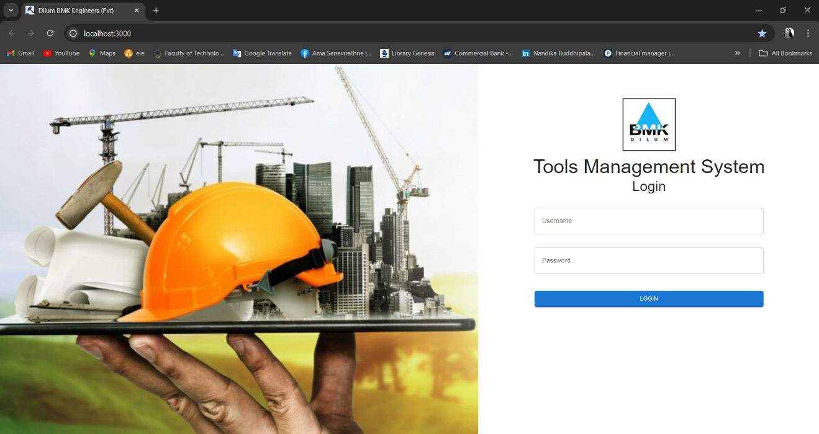

Figure 1- Login page of the Web application

3. Navigate to the dashboard according to role base.

1. **User Roles and Dashboards**

After logging in, you will be directed to your dashboard based on your role. Each role has specific features and access levels.

* Site Supervisor

Dashboard Overview: Shows site-specific information.

Features:

View and manage site activities.

Monitor site inventory.

Submit reports.

* Stock Supervisor

Dashboard Overview: Focuses on stock management.

Features:

View available tools and inventory.

Update stock levels.

Admin

Dashboard Overview: Full access to system settings and user management.

Features:

Add or remove users.

Assign roles and permissions.

Manage system settings and configurations.

**5. Troubleshooting**

Dashboard Access: Verify your role with the admin if you cannot access certain features.

Technical Issues: Clear your browser cache or try using a different browser.